EGE UNIVERSITY
LOGIC DESIGN LABORATORY
EXPERIMENT -8

Sequential Logic
../../…….

PRELIMINARY WORK

- Explain the differences between latches and flipflops. Emphasize the disadvantages of latches and explain how are they eliminated with latches.
- Explain the differences between master-slave and edge triggered flipflops.
- Explain the operation of the circuit given in fig-1. Discuss the behaviour of the circuit in fig-1 against the pulse transitions given below.

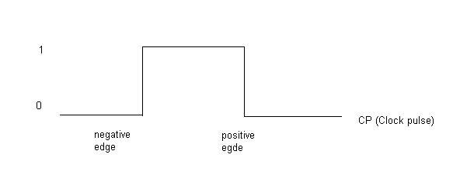

- Discuss the operation of the circuit given in fig-2 and comment on how this circuit differs from the flip-flops in operation principle.

EXPERIMENTAL WORK

- Connect the circuit given in fig-1 and observe the behaviour of the circuit against positive and negative transitions of clock pulse.
- Connect the circuits given in fig-2 and observe the operation of the circuit.

DISCUSSION

Discuss the importance of the duration of clock pulse on the proper operation of the flip-flop circuits.

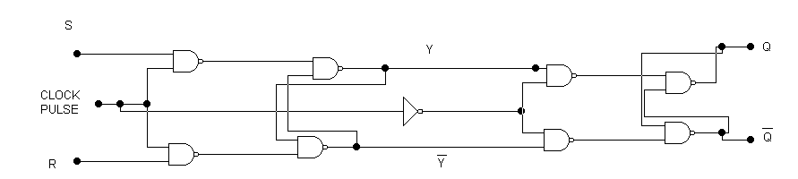

Fig. 1

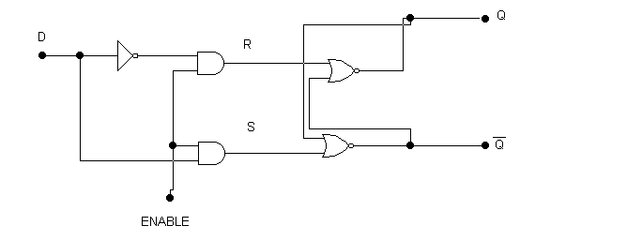
Fig. 2

